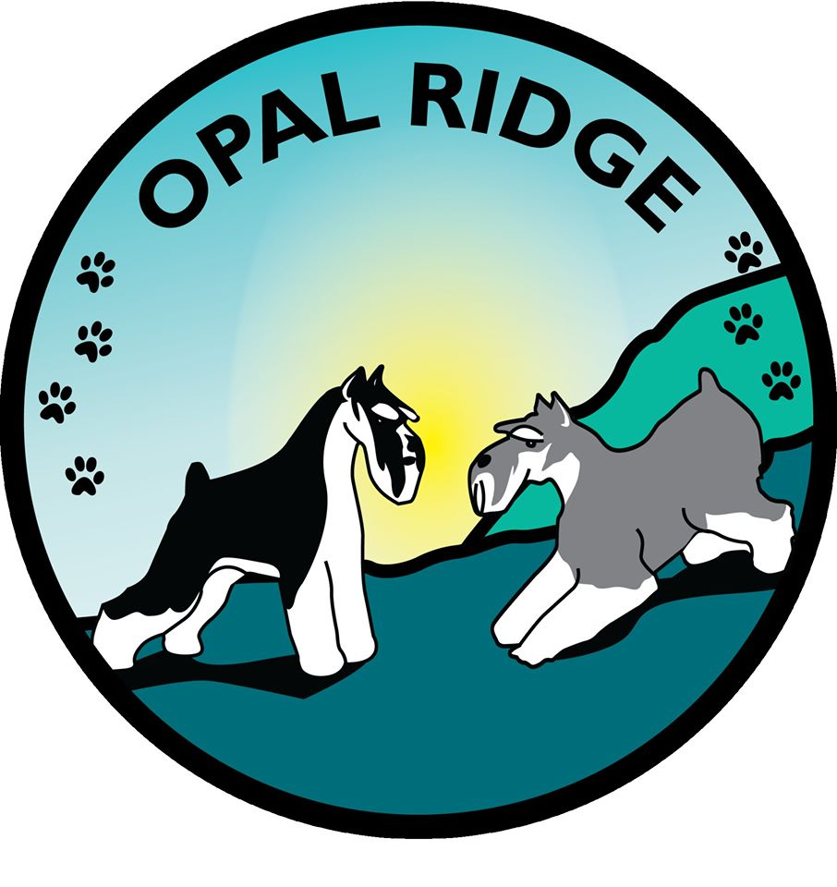
Grooming & Kenneling
Emergency Care Release Form

To whom it may concern: I have contracted for services with Opal Ridge Grooming & Kenneling during my absence and I authorize Opal Ridge or it’s duly authorized representative to act on my behalf to request veterinary treatment and services when, as and how they deem it necessary. I accept full responsibility for charges incurred in the treatment of my pet(s):

Special Instructions: ______________________________________________________________________________________________________________________________

I, __________________________________________________________ authorize Opal Ridge Grooming and Kenneling to treat my animal(s) and I will be fully responsible for all fees and charges and will pay for all charges that are incurred on my behalf, immediately upon my return.

Client: ______________________________________________________
Date:

Veterinarian:

Name:
Phone:
Address:

